  - Oil House
  - A 40-acre live/work project in Trenton, New Jersey connecting 292 unbuilt residences and families to 292 vacant buildings, four schools, one park, two businesses and one heaven.

Dreaming among Dreamers

Block 35401, Lot 7, is currently home to the New Jersey State Department of Corrections. As investors, city planners, non-profits, and even millennials scramble to define and construct the 21st century city, postindustrial landscapes have taken on new meaning.

Trenton is no exception to this reimagining.

The City of Trenton's official vision for Lot 7, or the Cadwalader Estates Redevelopment Plan, calls for residential use that preserves one or two historic properties for community use. The lot sits by prime area green, adjacent to Trenton's historic, 100 acre, Cadwalader Park, and key educational facilities including Joyce Kilmer Middle School, Trenton Central High School West Campus, and two elementary schools, Jefferson Elementary (public) and Christina Seix Academy (private).

We choose to dream and act in this very urban moment. We choose to dream among dreamers.

We envision the design and construction of 292 single-family residences, with plans to engage families that have committed not only to sustainable design in uniquely constructed one and two story container homes, but also collective economics, donating portions of their construction and future energy savings to the renovation of existing vacant properties, a total of 7.7% of Trenton's 3,804 abandoned buildings.

Each property sits on the minimum designated 6,000 square foot lot outlined in the city's redevelopment area. Our community center will serve as a design firm for this and future sustainable projects. Residents will be exposed to historic preservation and sustainable building standards, training in construction, socio-political and S.T.E.M, education programs, design arts, and more.

Of the two original structures, the Chapel and Mates Inn, a restaurant with an active culinary and hospital training program for current inmates, will remain, renovated with additions to accommodate the offices of One Heaven, Inc. and Oil House Productions, the construction training lab, and home theatre. A pedestrian walkway connecting the campus to area schools and open space will also be constructed.
"I Want One"
Building a neighborhood plan that takes into account gentrification’s deepening economic and political ramifications—like those of Trenton’s very own “Homesteading Plan”-- is urgent urban social justice/ resistance work. Our model(s), politic(s), commitments, and methods are informed by a range of intellectual, artistic, and socio-cultural “moves” that not only take this political reality to task, but do so with courage, conviction, and creativity. We are particularly (and humbly) indebted to Rhonda Y. Williams’ salient work on public housing, and to Camille Charles' sociological contributions in urban/suburban poverty. A neighborhood plan has never been adopted with uniquely Africana concepts of "neighborhood" and "home” as paradigm.
The catch phrase, "I Want One," is an implementation plan that connects 1 home, with 1 family and 1 local developer, while financing 1 local business. This framework keeps us invested across the community: across actors, visions, ambitions, and needs. It keeps us committed to our very particular urban space and moment. "I Want One" is a mission statement for postindustrial small city families and their futures.
Construction training and design curriculum are the strategic bases from which we move. Ten guaranteed properties owned by Bass Contracting will be transformed to rehabbed single-family and/or commercial spaces. The student curricula development is being adapted from, and in consultation with, Africana Studies colleagues at University of Pennsylvania, including Charles Herman Beavers and the late Terry Adkins, a scholar whose artistic works have been exhibited locally in Trenton, NJ before. It is a minimalist building plan for "container" development that highlights "sustainable" urban housing.
Part and parcel of reinhabiting space is reinhabiting ideas. We want our community to produce the knowledge that drives it. To make this possible, sociological, cultural, and political community initiatives, programs, and education courses will be integrated and nurtured within the public life of our neighborhoods.
The Logistics

The fundamental moving parts to this plan rest on three combining principles: Recycling, Rehabbing and Restoration. (Re)3 is a One Heaven and Oil House joint venture, in partnership with Westin Automotive, One Heaven, Inc. Will Holly, Zakiya Black, Esq. and Camille Charles, Ph.D.
With planning projects like Dorchester Project (Chicago), Adjaye's Sugar Hill (Harlem) and even Doha (Qatar), serving as cultural "neighborhood" models, Oil House is an architectural, political, and digital innovation. It is a neighborhood plan plus. Admittedly, then, this is a very “different” plan. It is built around creative capital resources of limited partners, and is poised to engage, service, and empower the many and competing needs of Trenton’s communities.
Working through the language and organizing strategies of affordable housing and workforce development, this joint initiative simultaneously pairs individual youth residents, families, community planners, and micro-businesses. We are advancing a co-op live/work arrangement that uses education and philanthropic equity as a wrap-around service to support low-income Trenton, NJ residents and "neighbors."
The "neighbor" requirement connects citywide block development that intuitively caps at the development of a discontinuous "neighborhood." We see West and South Trenton as ripe for our model.

Asbury Lane, Whittlesey Road, Stuyvesant Avenue

R3 is a live/work space running across 3 contiguous blocks that if enjoined would form a cultural neighborhood, or community. The model works like a Tri-fold: restoration of both a black urban middle class and an empowered agenda for the poor as the wings, with recycling and industry development at the center.
It is a plan that rests on three recycled entrepreneurial thoughts. One: Attract humble investors humbly, treat your $2000-$200,000 investor, single family, or Micro-business, like you would your one million private regional foundation investment. Protect and promote everyone's brand. Two: Leverage limited but powerful networks, including but not limited to, local Black Alumni Associations, social science research councils, University of Pennsylvania’s Center for Africana Studies, 100K "local" "neighborhoods." Three: Empower the theorization and realization of co-op's--Nu automotive, real estate investing, sustainable construction, Africana studies, urban planning, social service development, and infra politics can collective Reform. It is ultimately a very large-scale plan, only it pulls back stars on the way.
We have families in the city of Trenton who are committed to seeing transformation. They are invested in area schools, some shaping new curriculum along with charter school administrators, others actively seeking change in the form of "community school" models for public education. No doubt, recent years have been financially bleak and unforgiving, as the global rabidly shouts in the face of the everyday. The silver lining, or the radical promise of our increased vulnerability, is compelled to build beyond and around what was there, or rather, had never been there. We’ve been forced to innovate or die, to build new partnerships in the face of failing state services and institutions.
Our neighborhoods are surrounded by schools that work across barriers of public vs. private. The key to Joyce Kilmer Middle School, located to the left of the Department of Corrections site, is Principal Paula Bethea. Her leadership is evident in the vigor and rigor of her staff. What's missing among this neighborhood though, and throughout the city, are true pathways to education. We are an independent institution working to develop operations and capital projects among a diverse co-op. We are looking to fundamentally reorganize public options and support.
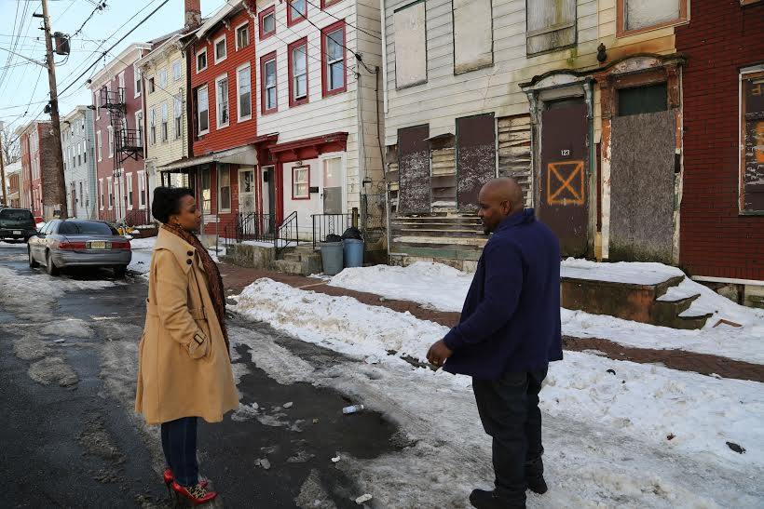
Tanji Gilliam with Andre Williams, One Heaven, Inc., 2014

Our Home
Oil House Productions uses engaged research models. We live urban ethnography. We perform participatory field work. Through the construction of “containers”-- literally assembling distinct plans with our starting lineup of seven partners--the earning potential of a small city is almost immediately transformed due to a discrete set of interconnected investors committed to pursuing collective economics models.
The sustainable construction keeps the co-op sound and equitable. It is as improvisational as jazz: my container home may not look quite like your container home, but the pieces fall together and it’s fair and consistent. Heating and other energy costs are regulated, design fees are minimal, plans are intricate, and consulting has exponential potential. You build plans ultimately, like an archive, over time.
We are motivated by the ambitious and boundary-defying work of notables like Zaha Hadid and David Adjdaye. We are motivated by the ambitious and boundary-defying work of notables like Zaha Hadid and David Adjdaye. We aim to experiment in community/political education, resource building, social scientific research, and digital innovation. We most certainly think global and act local.
For Africana art and architecture, the project advances global sustainability conversations by including black vernacular architecture in postindustrial cities. We are in conversation with, and grounded by, a rich sample of social and historical considerations: Harlem affordable housing initiatives, migration/demographic patterns, contemporary counter-movements on urban planning to name a few.
Our research and creative work has attracted interest from the Schomburg, Guggenheim, and other notable artistic and academic circles. Our media will continue to be displayed in independent film festivals (experimental and documentary categories) and via social networks. Oil House currently has a burgeoning following on Facebook (Oil House, Oil House Productions) YouTube (oilhousep) and Twitter (@oilhouse).
Cadwalader Park, 2014

Arts, Politics, and Culture

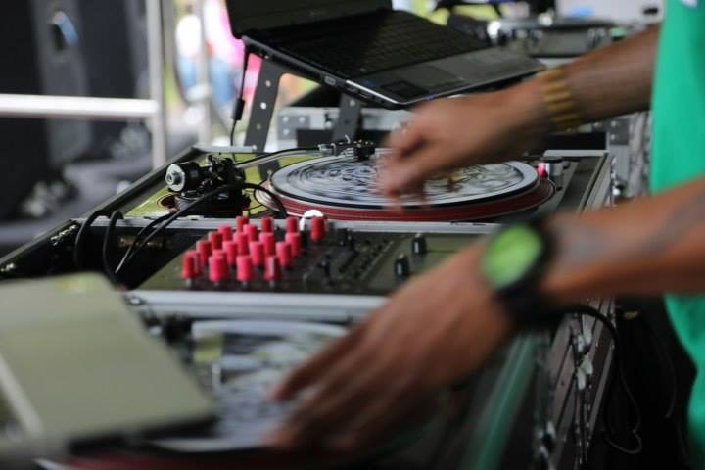
DJ Fatha Ramzee, 609 Media GFX, Cadwalader Park, 2014
We are firmly committed to Hip Hop and other socio-political, digital, and creative pursuits that empower. In the neighborhood surrounding Asbury St., extreme urban poverty, crime, and property abandonment (34 40 42 44 46. 47 49 48 50 52 54 56 57 58 60 61 62 64 66 68 70 72 69 -77 Asbury Street), is sandwiched in between large-scale "local" attractions, including Trenton Thunder and Sun Bank arena, fledgling eateries, occasionally partnering just to share/modify a liquor license as in the case of Conduit nightclub and Trenton Social. Local entrepreneurs still contend with discriminatory leasing policies, motivated by fears of crime, substance abuse violations, and a culture of exclusionary business practices that keep intensely marginalized black and Latino owned, and other low-income microbusinesses from the already inaccessible planning conversations.
Our plan integrates Todd Geter architects (Monument School, City Hall, Citiworks Carteret Avenue), DJ Fatha Ramzee (I Am Trenton, Mercer County Community College, Hip-Hop Press Conference), Oil House Productions, with STEM education research and development currently available with committed One Heaven partners and a dynamic local consultant, Manejay Lewis Nails, TechExplorers, NJ, who has formally worked in Rowan Towers (a West Trenton, affordable high-rise) and a number of other Trenton community sites.
Trenton Makes, the World Takes”
We’re making good on Trenton’s historic slogan. We are attuned to its Afrofuturistic possibilities. With 84,899 residents as of 2010, Trenton is both gateway and hub once again. While the city’s Master Plan calls for tax incentives for businesses to move in and aggressively promotes commuter culture, comprehensive plans must first speak to those 85,000 currently here, working, living, playing and praying.

We are One: working, living, playing, and praying in Trenton’s magic and her streets.

