University of Pennsylvania

The Myth of Haitian Liberation:

Hegel and the Iconographies of Blackness in French Revolutionary Visual Culture

by

Thadeus Dowad

Major: History of Art

College of Arts and Sciences ‘12

dowadt@sas.upenn.edu

(310) 748 - 5322

Philadelphia, Pennsylvania

Abstract

An undeniable paradox existed in eighteenth-century France between the escalating discourse of freedom and the continued practice of slavery in its Caribbean colonies. Even in the years after the French Revolution, in which the Enlightenment ideals of liberty, equality, and fraternity had become axiomatic, there remained a glaring lack of reconciliation between these principles and the continued enslavement of Africans in the sugar fields of Haiti; as such, the Haitian Revolution (1791-1804), in bringing about total manumission and bestowing citizenship across racial boundaries, can be understood as the first democratic revolution in Western history. This lecture examines one of the most famous paintings of the Haitian Revolution, Anne-Louis Girodet's Portrait of Citizen Belley, Ex-Representative of the Colonies (1797), within the paradigm of the Hegelian master-bondsman dialectic, exploring how the ontological conundrum of European self-identification vis-à-vis racial subjugation was articulated in French paintings of the Revolution. Itself inspired by the Haitian revolt, Hegel's ontology allows for an interpretation of Girodet's portrait as a failed portrayal of a liberated slave consciousness; by not only preserving the racist episteme of ancien régime depictions of Blacks, but by also evoking Black “liberatedness” solely through White signifiers, the image betrays a dialectic dependence on White cultural entities for the very understanding of Black freedom, both physical and metaphysical.

To construe Anne-Louis Girodet’s 1797 Portrait of Citizen Belley, Ex-Representative of the Colonies (Fig.1) as a “better-known exception” to the rule of Black representation in European painting is to misunderstand the nature of its singularity. To be sure, its portrayal of a Haitian revolutionary draped in the livery of a French citoyen guerrier is unique with respect to the visual culture of the era: heretofore Blackness had been defined largely by a limited set of pictorial tropes – the Negro as infantilized pet or the Negro as libidinous animal – and the French Revolution’s cri de cœur against despotism ultimately did little to undo its own “aristocracy of the skin,” a hierarchy of racial representation with Whites rendered the physical and moral superiors of Blacks. Both before and after the Revolution, the iconography of Blackness, comprised of the signifiers of and approaches to the representation of Blacks, was defined largely by a subjugation and inferiority to Whites, revealing a deep-seated racial prejudice on the part of Europeans.
However, Girodet’s image of the deputy Belley seems to combat this racial hierarchy. The disparagement and anonymity of Black representation are undone here by the power of the painted portrait, and the figure of Belley, strong and virile, is certainly at odds with the conventional image of the Negro pet. Yet while to paint Belley is to at once incorporate him into the revolutionary milieu, that Girodet, himself, is the painter here submits this incorporation to the conditioning of a White, French interpretive order. Despite its divergence from elements of traditional Black representation, Girodet's depiction still relies on the iconography of White revolutionary culture to define Belley’s liberated-Black identity, evincing a metaphysical relationship between the races.
One contemporary thinker to consider this metaphysical connection was G.W.F. Hegel. In Hegel’s presentation of the “intricate dialectic of dependence and independence,” which underpinned the master-slave mutual consciousness outlined in Die Phänomenologie des Geistes (1807), the philosopher provides a unique method for interpreting the visual culture of revolution and manumission. Hegel’s actual aesthetic ruminations offer little on the subject of image-making, but his take on the dynamics of intersubjectivity provides an avenue for visual culture historians to consider how the basic grammar of images – form, color, iconography, and so on - create (and sometimes dominate) their subjects. In the specific case of the Haitian Revolution (1791-1804), the Haitians’ deliverance from their “slave consciousness” and the emergence of the autonomous Black compelled a change in the representational system that had governed the representation of Africans prior to the revolution.
Girodet’s deviation from conventional representative systems, then, can be interpreted as an attempt to render Belley emancipated from Hegel’s slave consciousness. As the self conceives of itself through its relation to other selves, the conventional portrayal of Blacks as inferior or indebted to Europeans perpetuated, in Hegelian terms, their own slavehood. But in Girodet’s image, Belley is not subordinated to any White other. Rather, the master-slave dialectic is made visible in the depiction of Belley as an equal of his White counterparts, an attempt to detach consciousness from race through both the figure’s revolutionary attire and his relationship to the bust of the philosophe Guillaume Thomas Raynal. However, that the depiction of the “free Black man” necessitates the inclusion of these objects reveals a dependence on Whiteness for the very conceptualization of liberated Blackness. The uniform, tricolor sash, and pallid marble bust comprise his very liberty, and the removal of these extraneous signs would reduce him to an anonymous slave. Thus, the liberated Black retains some semblance of the slave consciousness because his very “liberatedness” is evoked through White signifiers. Moreover, Girodet’s attempt to eschew invidious pictorial approaches and render a new, refined Black image nonetheless results in the extension of other racist visions, namely the hyper-sexualized, animalistic brute. Ultimately, Girodet’s depiction fails to portray Belley as entirely free of the slave consciousness not only by preserving the racist episteme, but because the semiotics that defines his very freedom betrays a dialectic dependence on White entities.
While admittedly anachronistic, the application of Hegel’s master-slave dialectic to images surrounding the Haitian Revolution is validated by the influence the event played in the philosopher’s very conceptualization of the principle. A regular reader of the Masonic magazine Minerva, which from 1804 to 1805 contained a prolonged series of accounts on the Haitian struggle for independence, Hegel was aware of the Revolution while composing Die Phänomenologie des Geistes in Jena. Susan Buck-Morss has noted that the influence of the Haitian conflict is evident in the work’s particular attention to struggle. Anteceding treatises on slavery, namely those of Hobbes and Rousseau, had discussed slavery solely with regards to the nature of humanity, yet Hegel instead introduces slavery as an ontological struggle between master and bondsman. In doing so, Hegel brings the philosophical debate of slavery into the political realities of the day, a possibility unavailable to Hobbes and Rousseau, whose works predate the Revolution.
Besides Hegel’s reading of Minerva, prints of the Haitian Revolution had also begun to circulate in Germany by 1804. The initial uprising of 1791, in which Black slaves violently killed and tortured their White overseers, became a popular subject in European prints. A particularly graphic representation of the event depicts Black men raping White women and eviscerating others to “bodies in pieces.” (Fig. 2) Here, White control has been utterly quashed by the revolutionaries who vengefully subject their masters to their own torturous ways. Though the print’s artist remains unknown, it originated in Germany in the last decade of the eighteenth century, concurrent with Hegel’s drafting of Die Phänomenologie. Whether Hegel saw this particular print remains unclear, but that the events of the Haitian Revolution had by this time entered into German consciousness attests to a general awareness of the subject.
This connection to the revolution makes the application of the master-slave dialectic to the art of the period intellectually inviting, and if one excuses the anachronism, Hegel’s theory provides an insightful framework for evaluating Girodet’s attempted portrayal of a truly free Black. To begin, that Girodet desires to present Belley as an equal of the French is evident in the calculated extension of Republican emblems throughout the canvas. The marble bust of Raynal, at once an index of the abolitionist writer himself, who had detailed the maltreatment of Blacks in his Histoire des deux Indes (1770), and at the same time an emblem of the White French male, is notably set at the same height as the head of Belley. This planar alignment establishes a connection between the bust, its marble form imbued with the authority and erudition of antiquity, and Belley. In this relation, Raynal’s cerebral nature, designated by his classicism and exaggerated cranium, is imparted to Belley, who does not appear incapable of rational action, as the imperial slavery edict Le Code Noir had vehemently defended. He appears, rather, as a learned and sophisticated citoyen. Now a cerebral, rather than unrefined entity, Belley is liberated from his slave consciousness through the elimination of his “thingness,” that is, the physical labor and objecthood endemic to the slave consciousness. In the very act of rebelling, this former slave attained self-consciousness in the realization of his own agency, emphasized for the viewer in the juxtaposition of Raynal’s pallid lifelessness with the strong full body of Belley.
With the deputy’s selfhood determined by his physical and cognitive connection with the bust, the relationship of these two figures can be understood dialectically. The natural human condition, according to Hegel, is one of struggle, in which one self-consciousness seeks recognition in another, and this life-and-death struggle for mutual recognition is identified as the master-slave dialectic. Over the course of the conflict, one of the parties becomes unwilling to commit his life for the sake of recognition, thereby granting recognition to his “lord” in his very unwillingness to commit. The “slave” will work in service of the lord, whose own recognition is no longer conferred by an equal, but by a mere “tool” employed to provide for his needs.
In the alignment of Belley and Raynal, however, there is a decided attempt to challenge the identification of Belley with a mere “tool,” another designation of the aforementioned “thingness.” By granting him an agency uncharacteristic of the slave consciousness, portraying him instead as a liberated self-consciousness, the relationship of the two figures strives to neutralize race as an indicator of consciousness altogether. Indeed, the conventional depiction of Blacks as subservient became a means through which Europeans defined their own racial superiority, recognizing in the “thingness” of Blacks their own master consciousness. Accordingly, prior to the Revolution, depictions of Blacks were largely limited to images of “things” or possessions, namely young servant boys. As France’s encounter with Africans increased in the late seventeenth century, provincial governors, leading colonists, and outfitters of privateers gave Black children – predominantly boys – as gifts to the women of the French court. In a fashion popularized by the likes of Titian and Rubens, Black boy sitters were typically presented as accessories of French royalty, painted to highlight the “purity” and high status of their female keepers. Pierre Gobert’s Woman Washing the Face of Black Pageboy (Fig. 3) features such a pictorial trope, implying a contrast between the impossibility of making black skin white and the presumed beauty of the woman’s complexion.
In these Ancien Régime portraits, the exposition of “Blackness” derives from the omission of the sitters’ African heritage and the subsequent attribution of pre-existing European stigma. The history of violent capture, the forced separation of children from parents, and the brutality of the slave trade are all omitted – in fact, the forcible transportation of Africans across the Atlantic was never represented in the visual arts of France. Instead, depicting Blacks as servants or pets forged new associations in European minds between “Blackness” and the ignominy of servants; the Black race became synonymous with the lowly class of stewards and scullions. Regardless of race, the French middle and upper classes maligned their servants as unnaturally licentious, lazy, and moronic, and the image of the Black servant affixed these indignities to the Black race.
The techniques of omission and attribution used in these representations establish a two-fold inferiority to their White counterparts. On the one hand, the Blacks’ role as servants or infantile pets demonstrated an inferiority with regards to the natural order. Since servants, independent of race, sat on the lower rungs of the social hierarchy – a hierarchy believed to be reflective of the natural order – the depicted servants represented a subservience stemming from their own physical inferiority. On the other hand, their Black skin was employed fetishistically to accentuate the elegance and beauty of Whiteness. The binary of White and Black so prevalent in Gobert’s painting does not present the Black and White figures as equally beautiful, as though to suggest that the beauty of the White sitter is contingent on the presence of its opposite; rather the Black simply reinforces the beauty of the White, implicitly conceding Blackness’ own inferiority. Thinking back to Hegel’s schema, then, the pictorial system for depicting Black servants, with its omission of heritage and a priori attribution to class clichés, enforced the Blacks position as the metaphysical slave and thereby preserved the White self-understanding as master.
Girodet confronts this system’s Black and White binary directly in order to subvert its association of consciousness with race. As Europeans cognized their own selfhood with respect to the lowly status and race of their African counterparts, the appropriation of the Black and White juxtaposition to represent harmony rather than hierarchy here obviates any immediate apprehension of the White figure as master. One symbol used to appropriate this juxtaposition was the tricolor, converted into a sash and tied unceremoniously around Belley’s waist. Though a symbol of the alliance of France’s differently colored constituencies – blue for Black, red for Mulatto, and white for White – its equal panels of color belie the equality among the three racial groups. As such, Belley’s sash only features a small amount of red, showcasing instead far more of the banner’s blue and white panels. The tricolor, like the portrait, proposes a relationship between the two equally important parts of the Republic, Whites and Blacks, and consequently suggests a metaphysical equality, not a master-slave relationship, between the two races.

In contrast to pre-revolutionary depictions, Girodet’s portrait, with Belley and Raynal serving as the other Black and White parts, respectively, reflects a shift in the power dynamic of the dialectic. As Hegel theorizes, the “master,” in realizing that the recognition of his own selfhood is dependent on the existence of a slave to recognize him as such, ironically finds his being enslaved to the very “slavehood” of the bondsman; he had once believed himself as a being an sich, or in himself, but realizes his being is in fact for another. The slave simultaneously comes to conquer his initial fear of death through his labor, whereby he becomes aware of himself as an affirmation of the “masterhood” of the master and therefore capable of disturbing the relationship status quo. The slave takes on a new self-worth, creating a self-consciousness that ultimately undoes the master-slave relationship and eliminates the institution of slavery entirely. Moreover, this nullification of the dialectic is brought to bear in Girodet’s portrait, insofar as neither figure supports a master or slave consciousness; rather, their egalitarian relationship, echoed in the equal white and blue tricolor panels, provides for Belley’s self-consciousness of his free selfhood, a marked difference from the slave consciousness of the Black servants.
However, that Belley’s self-consciousness does not originate in himself, but is instead provided by Raynal complicates its meaning. As Darcy Grimaldo Grigsby notes, it is the Raynal bust, along with the portrait’s other French symbols, such as his clothing, tricolor sash, even earring, that provide for his agency and understanding as a freed slave. In Hegelian terms, then, Belley’s very self-consciousness is dependent on extraneous objects, because, as Gribsby argues, a Black without these White signifiers of liberty is nothing more than a slave.
Belley’s freedom, then, is one bestowed by the graces of a White other, a conceit in line with the iconography commonly used in depictions of Haitian emancipation. For example, an engraving of May, 1791, entitled Liberty in the Colonies (Fig. 4), depicts a fraternal embrace between a French soldier and a half-nude Haitian, as well as a French woman draping a military uniform over the bare shoulders of another native. While this is clearly a reverse of the Ancien Régime imagery of Blacks as possessions of female custodians, the sense of infantilization nonetheless remains. Liberty, here, is conferred by the French, not earned by the Blacks.
A similar message is conveyed in Guillaume Guillon-Lethière’s Oath of the Ancestors of 1822 (Fig. 5). The painting depicts the alliance between the mulatto officer Alexendre Pétion and the Black slave leader Jean-Jacques Dessalines. Pétion had defected from Napoleon’s army in 1802, and the subsequent alliance of mulatto and Black leaders led to the founding of the Haitian nation. This event is demarcated by the writing along the central stele, which reads: “L’union fait la force. Vivre libre ou mourir. Il n’y a de véritable liberté qu’avec le réligion…les loix…La Constitution.” Yet while the image may initially seem to attribute Haitian liberty to the military and diplomatic accomplishments of the revolutionaries, the soaring White Godhead hovering above and illuminating the scene implies that the Revolution remained incomplete without the recognition of the White father par excellence. It is by his grace – and his alone – that the revolutionary act is ordained as historical reality. Haitian emancipation becomes a gift, suggesting a continued subordination to a benevolent White.
Though free of any White paternalism, Girodet’s image still follows in the shadow of these representations, insofar as the present Black emancipation is inextricably tethered to White entities. Consequently, Belley’s agency and freed-slave self-consciousness become mere upshots of his exteriors. Even if, as Grigsby contends, the dead, stone bust of Raynal has no agency because it has been imparted entirely to Belley, that the agency was bestowed from Raynal at all suggests that the Belley-as-agent does not exist without its White referent. Moreover, Belley’s free self-consciousness is now paradoxically enchained to another consciousness, that is, Whiteness, for the existence of its own liberated selfhood. Belley is contradictorily at once free and dependent, or in other words, trapped in a freedom conditional on the subjection to a White other. Significantly, then, there is little evidence for self-determining Black freedom in Girodet’s work.
However, to say that the figure of Belley is self-conscious – and has thus terminated the master-slave dialectic – is simultaneously recognized and affected by the consciousness of Whiteness reveals the limitations of a pure Hegelian interpretation. As has been mentioned, the purpose of the liberation out of slavery is the elimination of the institution of slavery itself. Yet while the Haitian Revolution eventually brought an end to chattel slavery in the Caribbean island, Girodet’s portrait of the emancipated Belley does not entirely terminate the dialectic of lordship and bondage. While Belley’s spatial relationship with Raynal gives rise to the figure’s liberated self-consciousness, albeit one mitigated by its dependence on the relationship, itself, the figure’s pronounced genitalia in fact bring him back into the original dialectic, positioning him now as a master consciousness vis-à-vis his White audience.
The artist’s blatant sexualization of the Black deputy, endowing him with an overpowering masculinity, certainly undermines the physical primacy of his White audience. With Belley’s index finger curved into an arch-shape echoed in the flamboyant feathers of his tricorne, the outline of his large penis is boldly emphasized, and in doing so, Girodet’s painting violates traditional portrait canon with great aplomb. In the conventional treatment of the male organ, according to psychoanalyst Norman Bryson, the discrepancy between the image and the viewer’s sense of his own sexual power is resolved so that no discrepancy – and hence no anxiety – arises. Artists typically treat the difference between the image and the viewer so that the idealized genitalia do not compete with the viewer’s. However the figure of Belley, in guileless violation of this precept, threatens the male spectator with an unmistakable Black virility, forcing him to confront the insecurities of his own sexual potency.
Yet for Girodet, the genitalia do not merely invoke an intermale challenge, but an interracial one, as well. Art historian Helen Weston has proposed that the bust of Raynal is in fact modeled after an antique stone herm. These small statues were placed at crossroads to bestow blessings on passing wayfarers, and Girodet’s choice to transmute Raynal into an elaborate herm likely augurs Belley’s impending journey to France in 1797. Typically, these pillars were carved into a full male nude with an erect phallus protruding from the front; however, Weston argues that Girodet displaced the genitals onto the horizontal marble frieze just below the bust. The frieze’s repeated decorative motif, deviating from the typical egg-dart ornamentation of neoclassical design, in fact appears as reiterated penis and testicles (Fig. 6). Just as the two figures’ heads are placed at the same height, so this motif and Belley’s genitalia share a common plane, inviting a direct contrast between these symbols of White and Black masculinity. Effectively, the juxtaposition of small White genitalia and large Black genitalia advanced in Weston’s interpretation can be grasped as evidence of a larger master-slave conflict. In Hegelian terms, Belley’s superior masculinity can be regarded as a physical instantiation of his master consciousness. In this interpretation, Raynal, a metonymy of Whiteness, is emasculated by the contrast in genital size, and as the White viewer recognizes his consciousness in that of the pallid bust, he is forced into a slave consciousness, himself.
However, this construal of a racial conflict between Raynal and Belley, with the latter embodying the master consciousness, is irreconcilable with the spatial and metaphysical equivalence on the two figures. Moreover, the very notion of White subordination by means of a superior Black physiognomy de-contextualizes Black sexuality from the genealogy of its own representation. Indeed, associations of Blackness with licentiousness and animalistic brutality had infiltrated French visual culture as early as 1791, and Belley’s prominent penis threatened to subordinate him to this racial typology. In opposition to Weston’s argument, then, the genitalia do not provoke an anxiety among the portrait’s audience, but rather in their beastly appearance, substantiate the notion of Blacks as biologically inferior.
During and after the Revolution, this perception of genetic inferiority specifically catalyzed the popular image of the simian Black. Jean-Michel Moreau’s 1803 print illustration for a publication of Voltaire’s Candide (Fig. 7) presents this image in its spectacle of interracial sexuality between Black men, represented as monkeys, and White women. The racist episteme in France, forged largely by reports of rape and violence in Saint Domingue, prompted a reading of these monkeys not simply as male, but as Black males. Indeed, the episteme emerged primarily from the events of the Haitian Revolution, itself; earlier depictions of monkeys, such as in Charles Monnet’s 1777 illustration of the same scene (Fig. 8), instead depict the creatures as entirely non-threatening. In Monnet’s print, the symbol of the monkey had a metonymic association with Africa solely and not with its inhabitants; however, with Moreau’s menacing monkeys, a shift from metonymy to metaphor had occurred, with the monkey now directly representing the Black male. Voltaire’s original scene of polygenesis was here transformed into an image of interracial sex, with Candide, the prototypical White patriarch, upholding the honor of the assaulted women. European fears and conceptions of racial superiority converged here in the creation of the Black as animal.
In addition, this image of the predatory Black ape, shaped specifically by accounts of sexual violation on the part of the Haitian revolutionaries, remains inextricable from the portrait of Belley, insofar as the deputy was himself one such revolutionary. Accordingly, though his prominent penis was perhaps intended as a sign of self-regulated sexual potential, as Grigsby insists, it nonetheless became a confirmation of the same Haitian carnality fundamental to the character of the simian Black. The inseparability of the genitalia from these pre-existing understandings of Black sexuality ultimately subject Belley to the racist episteme, which construed him as a brutish animal. Therefore, in complete opposition to Weston, who interprets the penis as the source of a Black master consciousness, Belley and the Black sexuality are in fact subjected to a typology. Black physicality and the lechery of the Black-as-ape become one. Thus, in addition to a reliance on Whiteness for the recognition of his own freedom, Belley’s manhood is also subjected to White prejudices that sublate his sexuality into an animalistic stereotype.
What remains, then, is a reading of Girodet’s Belley as an imperfect attempt at the depiction of an independent Black self-consciousness. While Belley is at once emancipated from the slave consciousness so characteristic of Black representation, he is still subjected to, on the one hand, prejudicial associations and, on the other hand, Whiteness for the establishment of his very freedom. Hegel’s master-slave dialectic here serves as a profound interpretive system, not only allowing for an evaluation of Black and White iconography, but also revealing the paradoxical consciousness of Belley in Girodet’s portrait; he is at once both slave and self-conscious. The deputy, though not directly subordinated to any White other, as with the Blacks in Ancien Régime portraiture, remains reliant on White signifiers for the conceptualization of liberated Blackness. In a way, then, Belley retains some semblance of the slave consciousness because of this very dependence, and Girodet’s attempt to dissociate consciousness from race proved impossible, as he could only conceive of liberty in racially-fixed iconographies. Therefore, the Hegelian interpretation of this image ultimately reveals that Haitians, even in the wake of universal emancipation, would retain some essence of a slave consciousness due to the French’s inability to conceive of Black liberty independent of its own pictorial systems.

Figure 1:

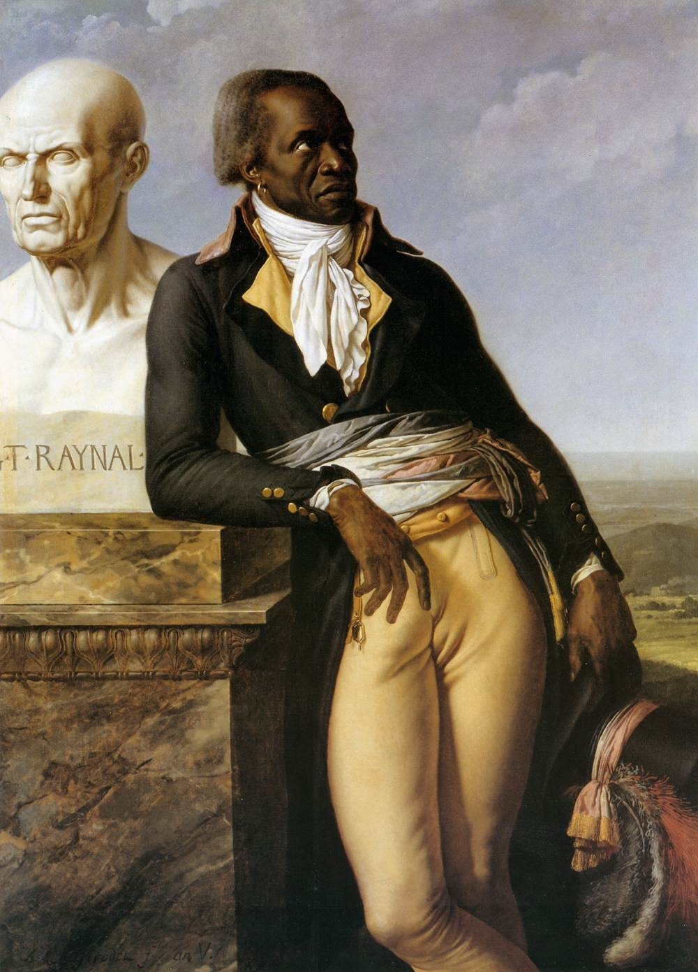

Citoyen Jean-Baptiste Belley, Ex-Representative of the Colonies
Anne-Louis Girodet, 1797
Oil on canvas, Versailles, Musée National de Château

Figure 2:

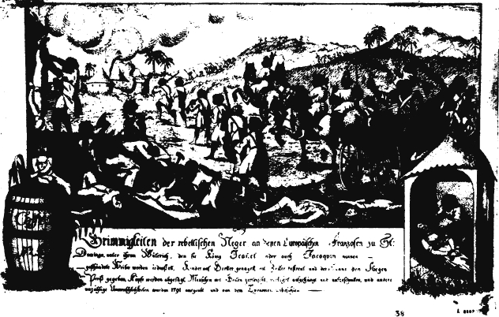

Revolt of the Blacks at Saint-Domingue, Scene of Atrocities 1791
Anonymous (German), c.1791
Engraving, Bibliothèque Nationale, Paris

Figure 3:

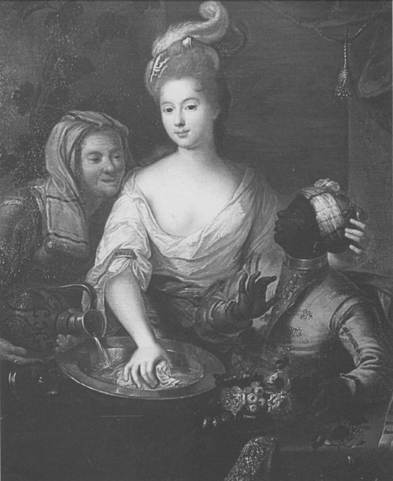

Woman Washing the Face of a Black Pageboy
Pierre Gobert (attr.), 18th century
Oil on canvas, Private Collection

Figure 4:

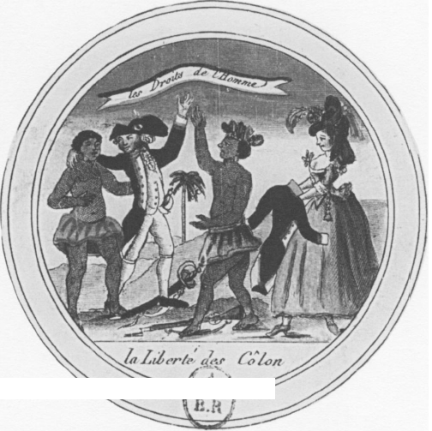

Liberty of the Colonies
Anonymous, 1791
Engraving, Bibliothèque Nationale, Paris

Figure 5:

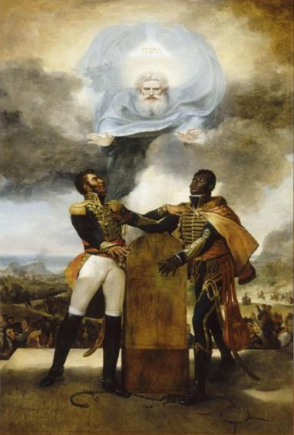

Oath of the Ancestors
Guillaume Guillon-Lethière, 1822
Oil on canvas, Palais National, Port-au-Prince, Haiti

Figure 6:

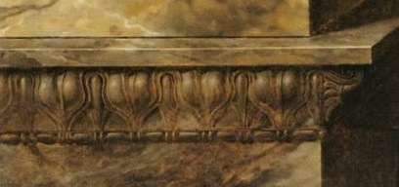

Citoyen Jean-Baptiste Belley, Ex-Representative of the Colonies (Detail)
Anne-Louis Girodet, 1777
Oil on canvas, Versailles, Musée National de Château

Figure 7:

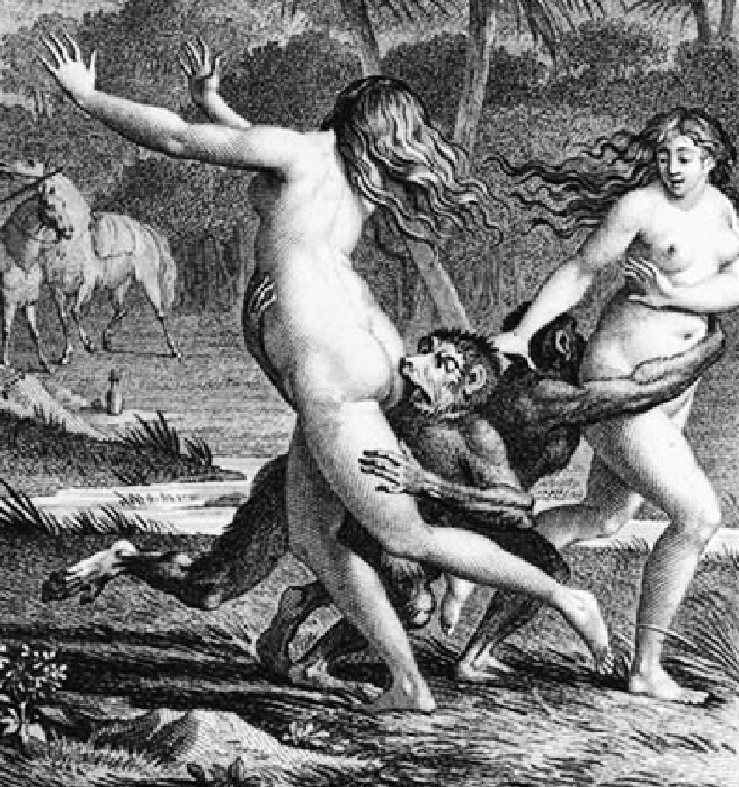

“The Two Wanders Heard a Few Little Cries”
Emmanuel de Ghendty after Jean-Michel Moreau le Jeune, 1803
Engraving, Bibliothèque Nationale, Paris

Figure 8:

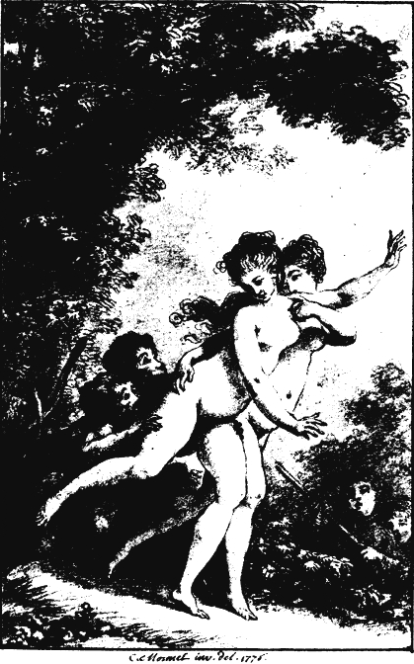

“The Two Wanders Heard a Few Little Cries”
Charles Monnet, 1776
Engraving, Bibliothèque Nationale, Paris

Bibliography

Bellhouse, M. L. "Candide Shoots the Monkey Lovers: Representing Black Men in Eighteenth-Century French Visual Culture." Political Theory 34.6 (2006): 741-84.

Berger, Klaus, and Diane C. Johnson. "Art as Confrontation: The Black Man in the Work of Gericault." The Massachusetts Review 10.2 (1969): 301-40.

Buck-Morss, Susan. Hegel, Haiti and Universal History. Pittsburgh, PA: University of Pittsburgh, 2009.

Camara, B. "The Falsity of Hegel's Theses on Africa." Journal of Black Studies 36.1 (2005): 82-96.

Dienstag, Joshua Foa. "Building the Temple of Memory: Hegel's Aesthetic Narrative of History." The Review of Politics 56.04 (1994): 697.

Gandelman, C., and I. Klein. "Hegel's Dialetic of Master and Slave as a Model for the Relation between Artistic Creation and Aesthetic Appreciation." Philosophy & Social Criticism 5.1 (1978): 36-45.

Gilman, Sander L. "The Figure of the Black in the Thought of Hegel and Nietzsche." The German Quarterly 53.2 (1980): 141-58.

Grigsby, Darcy Grimaldo. "Revolutionary Sons, White Fathers, and Creole Difference: Guillaume Guillon-Lethière's "Oath of the Ancestors" (1822)." Yale French Studies 101 (2001): 201-26.

Grigsby, Darcy Grimaldo. Extremities: Painting Empire in Post-revolutionary France. London: Yale UP, 2002.

Moyar, Dean, and Michael Quante. Hegel's Phenomenology of Spirit: a Critical Guide. Cambridge: Cambridge UP, 2008.

Munro, Martin, and Elizabeth Walcott-Hackshaw. Reinterpreting the Haitian Revolution and Its Cultural Aftershocks. Kingston, Jamaica: University of the West Indies, 2006.

Smith, Steven B. "Hegel on Slavery and Domination." The Review of Metaphysics 46.1 (1992): 97-124.

Weisberger, Richard William., Dennis P. Hupchick, and David L. Anderson, ed. Profiles of Revolutionaries in Atlantic History, 1700-1850. Boulder: Social Science Monographs, 2007.

Weston, Helen D. "Representing the Right to Represent: The "Portrait of Citizen Belley, Ex-Representative of the Colonies" by A.-L. Girodet." RES: Anthropology and Aesthetics 26 (1994): 83-99.

Darcy Grimaldo Grigsby, "Revolutionary Sons, White Fathers, and Creole Difference: Guillaume Guillon-Lethière's "Oath of the Ancestors" (1822)." Yale French Studies 101, 2001: 205.
Darcy Grimaldo Grigsby, Extremities: Painting Empire in Post-revolutionary France (London: Yale University Press, 2002), 14.
Ibid., 32.
The Phenomenology of Spirit, trans. A.V. Miller (Delhi: Shri Jainendra Press, 1998) 111.
Steven B. Smith, "Hegel on Slavery and Domination." The Review of Metaphysics 46.1, (1992): 101.
Buck-Morss, Hegel, Haiti and Universal History, 42.
M. L. Bellhouse, "Candide Shoots the Monkey Lovers: Representing Black Men in Eighteenth-Century French Visual Culture," Political Theory 34.6, (2006): 760.
Bellhouse, "Candide Shoots the Monkey Lovers: Representing Black Men in Eighteenth-Century French Visual Culture," 767.
Buck-Morss, Hegel, Haiti and Universal History, 55.
Ibid., 54.
The Phenomenology of Spirit, trans. A.V. Miller, 104.
Ibid., 118.
Ibid., 744.
Helen D. Weston, "Representing the Right to Represent: The ‘Portrait of Citizen Belley, Ex-Representative of the Colonies’ by A.-L. Girodet," RES: Anthropology and Aesthetics 26, 1994: 89.
Marcus Wood, Blind Memory: Visual Representations of Slavery in England and America 1780-1865 (New York: Routledge, 2000) 18-21.
Grigsby, Extremities: Painting Empire in Post-revolutionary France, 16.
Cissie Fairchilds, Domestic Enemies: Servants & their Masters in Old Regime France (Baltimore: Johns Hopkins University Press, 1984), 145-148.
Ibid., 158.
Grigsby, Extremities: Painting Empire in Post-revolutionary France, 21.
Ibid., 22.
Smith, "Hegel on Slavery and Domination," 103.
The Phenomenology of Spirit, trans. A.V. Miller, 522-523.
Grigsby, Extremities: Painting Empire in Post-revolutionary France, 32.
Ibid.
“Union makes strength. To live free or die. There is no true liberty except with religion…laws…The Constitution.”
Grigsby, "Revolutionary Sons, White Fathers, and Creole Difference: Guillaume Guillon-Lethière's ‘Oath of the Ancestors’ (1822)," 216.
Grigsby, Extremities: Painting Empire in Post-revolutionary France, 19.
Buck-Morss, Hegel, Haiti and Universal History, 56.
Norman Bryson, “Gericault and ‘Masculinity’,” Visual Culture: Images and Interpretations, ed. Norman Bryson, Michael Ann Holly, and Keith Moxey (Hanover: University Press of New England, 1994) 235.
Bellhouse, "Candide Shoots the Monkey Lovers: Representing Black Men in Eighteenth-Century French Visual Culture," 767.
Weston, "Representing the Right to Represent: The ‘Portrait of Citizen Belley, Ex-Representative of the Colonies’ by A.-L. Girodet," 98.
Ibid.
Grigsby, Extremities: Painting Empire in Post-revolutionary France, 55.
Bellhouse, "Candide Shoots the Monkey Lovers: Representing Black Men in Eighteenth-Century French Visual Culture," 776.
Ibid.
Grigsby, Extremities: Painting Empire in Post-revolutionary France, 55.

